**CENWP-OD-J March 29, 2022**

**MEMORANDUM FOR THE RECORD**

**SUBJECT: 22JDA02 North Fish Pumps Tripped**

At approximately 0456 on Tuesday March 29th the north fish ladder (NFL) auxiliary water supply pumps tripped due to interference from barge radio waves. In order to get better clarification on the issue we consulted one of our electricians, and here is how he explained it.

“The navigation radars of the barges produce electromagnetic radiation (radio waves) at sufficient power to induce voltage potentials into the pump controller equipment.  These induced charges act as electrical “noise” in the computer portions of the controllers.  The computer can’t distinguish between what is a real signal and what is noise, so the noise can act like a real signal.  The random noise gets interpreted by the computer in any number of ways, for instance, it could “see” a stop command, or it could interpret a fault, say, an overload, an under speed, etc.. It is random how the computer interprets it since noise is not consistent.  So, the most effective way to keep the electrical noise out of the building is to keep the doors shut. This proves as a challenge since the ac units are out of service.”

In addition, since these radio waves are potentially harmful to humans, barges are required to turn off their radar equipment before entering the navigation lock. The barge on the 29th didn’t comply with this requirement causing the NFL pumps to trip off. The barge operator was notified of this afterwards by John Day operations of the requirement.

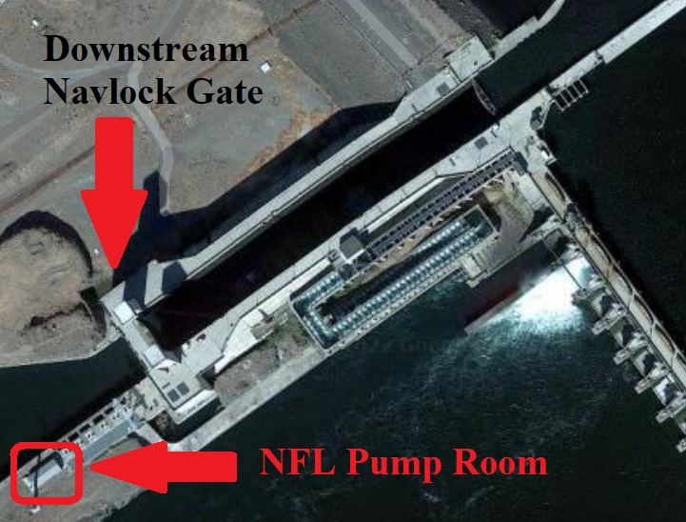

1. Species – All
2. Origin – Unknown
3. Length – Unknown
4. Marks and tags – Unknown
5. Marks and Injuries found on carcass – N/A
6. Cause and Time of Death – N/A
7. Future and Preventative Measures – John Day operators will remind barge operators of the requirement and check the pumps after locks to ensure they’re running. Additionally, fisheries staff will check the SCADA system more frequently to ensure the NFL stays in FPP criteria.

Sincerely,

JD Project Fisheries

**Comments from others –**

-----Original Message-----  
From: Grosvenor, Eric G CIV (USA) <Eric.Grosvenor@usace.army.mil>   
Sent: Thursday, March 31, 2022 7:29 AM  
To: Blane Bellerud - NOAA Federal <blane.bellerud@noaa.gov>; Mackey, Tammy M CIV USARMY CENWP (USA) <Tammy.M.Mackey@usace.army.mil>  
  
Subject: RE: [Non-DoD Source] Re: FPOM: Official Coordination - 22JDA02 MFR North Fish Pumps Tripped

Blane,

Yes, human error. Barge operators are required to turn their radar off while in the navigation lock area. They were informed of the incident and the requirement.

I don’t think we need to look at deflectors or signs, tug captains are experienced professionals and after and extended nav lock outage I’d think this was an honest mistake. However, we’ll remind them on their approaches for the time being of the requirement

V/R

Eric Grosvenor

Fish Biologist

USACE John Day Dam

O 541 739 1063

C 541 499 7057

From: Blane Bellerud - NOAA Federal <[blane.bellerud@noaa.gov](mailto:blane.bellerud@noaa.gov)>

Sent: Thursday, March 31, 2022 6:56 AM

To: Mackey, Tammy M CIV USARMY CENWP (USA) <[Tammy.M.Mackey@usace.army.mil](mailto:Tammy.M.Mackey@usace.army.mil)>

Subject: [Non-DoD Source] Re: FPOM: Official Coordination - 22JDA02 MFR North Fish Pumps Tripped

Yeah, if the radar is strong enough to affect pumps it is also likely not doing dam personnel any good either. So this was just human error? I suggest the COE remind all the lock users about turning their navigation radar off. Maybe even a big sign on the north bank of the river. It is possible to install radar detectors or shield the pump equipment but if you can ensure compliance with the no radar rules that might not be neccessary

Blane

USFWS

-----Original Message-----  
From: Swank, David R <david_swank@fws.gov>   
Sent: Friday, April 01, 2022 10:44 AM  
To: Mackey, Tammy M CIV USARMY CENWP (USA) <Tammy.M.Mackey@usace.army.mil>; Subject: [Non-DoD Source] Re: [EXTERNAL] FPOM: Official Coordination - 22JDA02 MFR North Fish Pumps Tripped

Tammy,

This MFR regarding ship’s radar causing induction in the fish pumps reminds me of interference issues that simple PIT tag antennas can have from ground based radar systems. It also reminds me of a pilot study that the NOAA SWFSC did several years back to try to track juvenile steelhead after they reached the ocean. They had put acoustic tags in these fish, but steelhead go far out to sea very quickly, and they weren't getting any detections of California steelhead from the POST array of receivers. So they decided to attach receivers to local pinnipeds, and let the sea lions be mobile acoustic receiving stations. As I recall, they actually recorded a few detections, but not enough to continue the study. Maybe we could use the barges that continually ply the Columbia and Snake rivers, and find a way to attach PIT tag antennas to them that would detect any tagged fish they encountered. Unlike the sea lions, we know their ranges will continually overlap with PIT tagged fish migrating in the river. This would surely solve the issue of decreased tag detections we've had the last couple of years. We could call the system the Floating Onboard Online Large Sensor array. What do you think?

Happy 1st everyone!

Dave

David Swank, Ph.D., he/his

Fish Biologist | US FISH & WILDLIFE SERVICE

[David_Swank@fws.gov](mailto:David_Swank@fws.gov) <<mailto:David_Swank@fws.gov>> | [www.fws.gov/columbiariver/](http://www.fws.gov/columbiariver/) <Blockedhttp://www.fws.gov/columbiariver/>

360.604.2500 office | 360.604.2520 direct

Columbia River Fish and Wildlife Conservation Office

1211 SE Cardinal Court, Suite 100, Vancouver, WA 98683